**Section 1–6B: Absolute Value Inequalities**

The solutions of the absolute value inequality $\left|x\right|<5$ include values greater than $-5$*and* less than $5$. This is the compound inequality $x>-5$*and $x<5$* , which you can write as $-5<x<5$. So, $\left|x\right|<5$ means $x$ is between $-5$ and $5$.

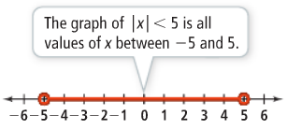

Therefore, you can write an absolute value inequality as a compound inequality without absolute value symbols.

**Example 1: Solving the Absolute Value Inequality $\left|A\right|<b$**

What is the solution of $\left|2x-1\right|<5$? Graph the solution.

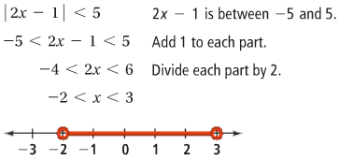

$\left|x\right|<5$ means $x$ is between $-5$ and $5$. So, $\left|x\right|>5$ means $x$ is outside the interval from $-5$ to $5$. You can say $x<-5$*or $x>5$* .

**Example 2: Solving the Absolute Value Inequality $\left|A\right|≥b$**

What is the solution of $\left|2x+4\right|≥6$? Graph the solution.

